Deliverable II

**Interviews and Use Case**

**Gym Modernization**

_____________________________________ By: ___________________________________

Alek Babeki

Daniel Cunningham

Jay Early  
Tom Irwin  
Akram Khan

Pratik (PK) Padhiyar

Interview Highlights:

**Interviewee 1: Marketing Director, Rex Kwon**

**Interviewer:**

Q: Are you interested in knowing the age ranges of people who are trying to join?

A: Yes! It would help us to improve our equipment and focus group.

Q: How often are people paying?

A: Monthly, or a yearly subscription.

Q: Is your website attractive to potential new customers?

A: I believe it is, however, there needs to be more interactive features such as logins and clickables etc. Also, I do not want our prices on the site, the interactive features and member benefits section is enough and they can click a button for scheduling a visit.

Q: Do you have any particulars regarding the channel in which you market and who you market toward?

A: Yes, as our budget is not large, we have a commercial that airs twice per month. We have the video on file and was hoping we could have add it to the more cost effective internet marketing. We are marketing to all age ranges but want to become more trend forward with the crowds between ages 18 - 40.

**Notes:** The age range of customers is wide for this gym and it’s hard to know who comes when. The marketing director has a website for the gym but it’s very basic and doesn’t allow much interaction for the customers. Marketing is not very efficient with the budget they have but could be improved to attract more clients.

**Interviewee 2: Operations Specialist**

Q: Is your transaction processing system lacking in any way?

A: It is very simple, in store cash or credit system.

Q: Is your website efficient with information?

A: Our website has our location, how to get here, basic equipment list, and our rates.

Q: Is it difficult to check if everyone entering the gym with expired memberships?

A: It is very difficult.

Q: Have you guys looked into the cost of expanding your gym? Another location?

A: The cost and time for opening another gym isn’t too bad right now but the main issue we would face is being able to transfer data from one gym to the other. It’s doable but way too time consuming.

**Notes:** Operations are very basic at the gym. They have the minimal amount of information regarding their service. Their logging information is an old school style and not very efficient at the moment, making it even more difficult to expand or grow to other locations.

**Interviewee 3: Personal Trainer**

Q: What equipment is used the most, throughout the entire day?

A: Oh it’s impossible to track that, people come in everyday and use random assortment of machines.

Q: How many customers do you typically train during any given day?

A: Between my hours I probably train around 12 or so, I try to do two people an hour but it will go over sometimes.

Q: Does your gym hold fitness classes?

A: Yes, we do hold classes. There are daily classes in various rooms at the gym.

Q: Do these classes ever fill up completely?

A: They can fill up frequently depending on the topic.

Q: How do you track how many people are in the class?

A: We physically take a headcount. This takes up the first 5 minutes of the class as people enter.

Q: Do these classes ever go over their capacity limits?

A: All the time but we don’t find out until it’s too late.

Q: What kind of improvements would you like to see?

A: I’d love to have a better scheduling system for my clients as well as other personal trainers, we only have a couple.

Q: What problems do you deal with or see?

A: The main problem I deal with is that some days I get a overflow of clients and some days I hardly see 4. Even though I give them my schedule, I feel as though they do not pay too much mind to it.

**Notes: .**

**Interviewee 4: Manager**

Q: How many receptionists do you normally have working at the same time?

A: Two receptionists at a time.

Q: What are your busiest days?

A: Thursday and Fridays

Q: Are you aware of which hours are busiest on any given day?

A: Yes, typically from 4-8 AM, as well as 3-9 PM.

Q: How quantifiable is the data?

A: Not very. We gauge it visually.

Q: How many people typically enter your gym on a daily basis?

A: Approximately 200.

**Notes:**

**Interviewee 5: Current Gym Member**

Q: How long have you been attending this gym?

A: A couple months

Q: How would you describe your experience with the log-in system?

A: It’s been alright, It’s kind of annoying to see people sneak in all the time when I bring my card all the time though.

Q: We are currently in the process of planning to revamp our system. How do you feel about an easier log-in and log-out system?

A: Of course, that would be much easier and less time-consuming!

Q: How would you describe your gym schedule here?  
A: Well I try to come every day, but sometimes it’s very busy and I don’t get as good of a workout.

Q: Are you usually aware when the gym is busy?

A: It’s pretty much a gamble. I really wouldn’t know what time is best to come in.

**Notes:** Gym members are unable to have a consistent schedule at the gym. A solution for this could be online access to the gyms availability. The system they have at the gym makes it tedious to clock in and out.

## Use Cases

|  |  |
| --- | --- |
| Last updated by: | Akram Khan |
| Date Last Updated: | 3/9.18 |
|  |  |
| Use Case ID: | 2 |
| Use-Case Name: | Membership Card Issue |
| Created By | Java Tech |
| Date Created | 3/9/2018 |
| Actor | Gym member |
| Description | A member has an issue paying with a credit card or debit card. |
| Preconditions | Credit card can't be processed by Rock Creek Sports Club |
| Post Conditions | Transaction issues are resolved by system. |
| Priority | Very High |
| Frequency of Use | Every 30 min |
| Normal Course of Events | 1. Use case begins when a gym member has issues with Rock Creek accepting their payment. 2. Gym assists with payment issues through web application. 3. Use case ends when issue is resolved. |
| Alternative Courses |  |
| Exceptions | Payment such as credit card number or security code is invalid or declined. Card can also be expired. |
| Includes | 2 |
| Special Requirements | A valid credit card or debit card is required with security code. |
| Assumptions | Memberships cost $69.99 and can be purchased online through a form. |
| Notes and Issues |  |

|  |  |
| --- | --- |
| Last updated by: |  |
| Date Last Updated: |  |
|  |  |
| Use Case ID: | 3 |
| Use-Case Name: | Check in/out |
| Created By | Java Tech |
| Date Created | 3/7/2018 |
| Actor | Gym member, Personal trainer |
| Description | Member logs into system to track progress, make |
| Preconditions | No date and time is selected for appointment |
| Post Conditions | A member will be able to book an appointment |
| Priority | High |
| Frequency of Use | Every few minutes |
| Normal Course of Events | Gym member scans their card in |
| Alternative Courses | Gym member provides credentials to look up account |
| Exceptions | Gym member forgot their card |
| Includes |  |
| Special Requirements | Gym members must have a valid membership |
| Assumptions | Gym members carry their ID cards with them |
| Notes and Issues |  |

|  |  |
| --- | --- |
| Last updated by: |  |
| Date Last Updated: |  |
|  |  |
| Use Case ID: | 1 |
| Use-Case Name: | Online Interaction |
| Created By | Java Tech |
| Date Created | 3/7/2018 |
| Actor | Gym member, Receptionist, Personal trainer |
| Description | The gym member logs into his/her account to set up an appointment with a personal trainer or sign up for a class |
| Preconditions | No date and time is selected for appointment |
| Post Conditions | A member will be able to book an appointment |
| Priority | High |
| Frequency of Use | Every few minutes |
| Normal Course of Events | Use case begins when a gym member reaches the login page |
| Alternative Courses |  |
| Exceptions | Gym member forgot their ID login (look up account) |
| Includes |  |
| Special Requirements | Gym members must have a valid membership |
| Assumptions | Gym members remember their login information |
| Notes and Issues |  |

|  |  |  |  |
| --- | --- | --- | --- |
| UC Name: | Review payment options | ID: UC-1 | Prority: High |
| Actor: | Gym Member |  |  |
| Description | The gym member is the client which comes to the club to workout and access varying information regarding their accounts. |  |  |
| Trigger | Needs to change payment method |  |  |
| Type: | External |  |  |
| Preconditions: | Must have a valid credit card number. User ID. Not delinquant over 30 days. |  |  |

## Use Case Diagrams

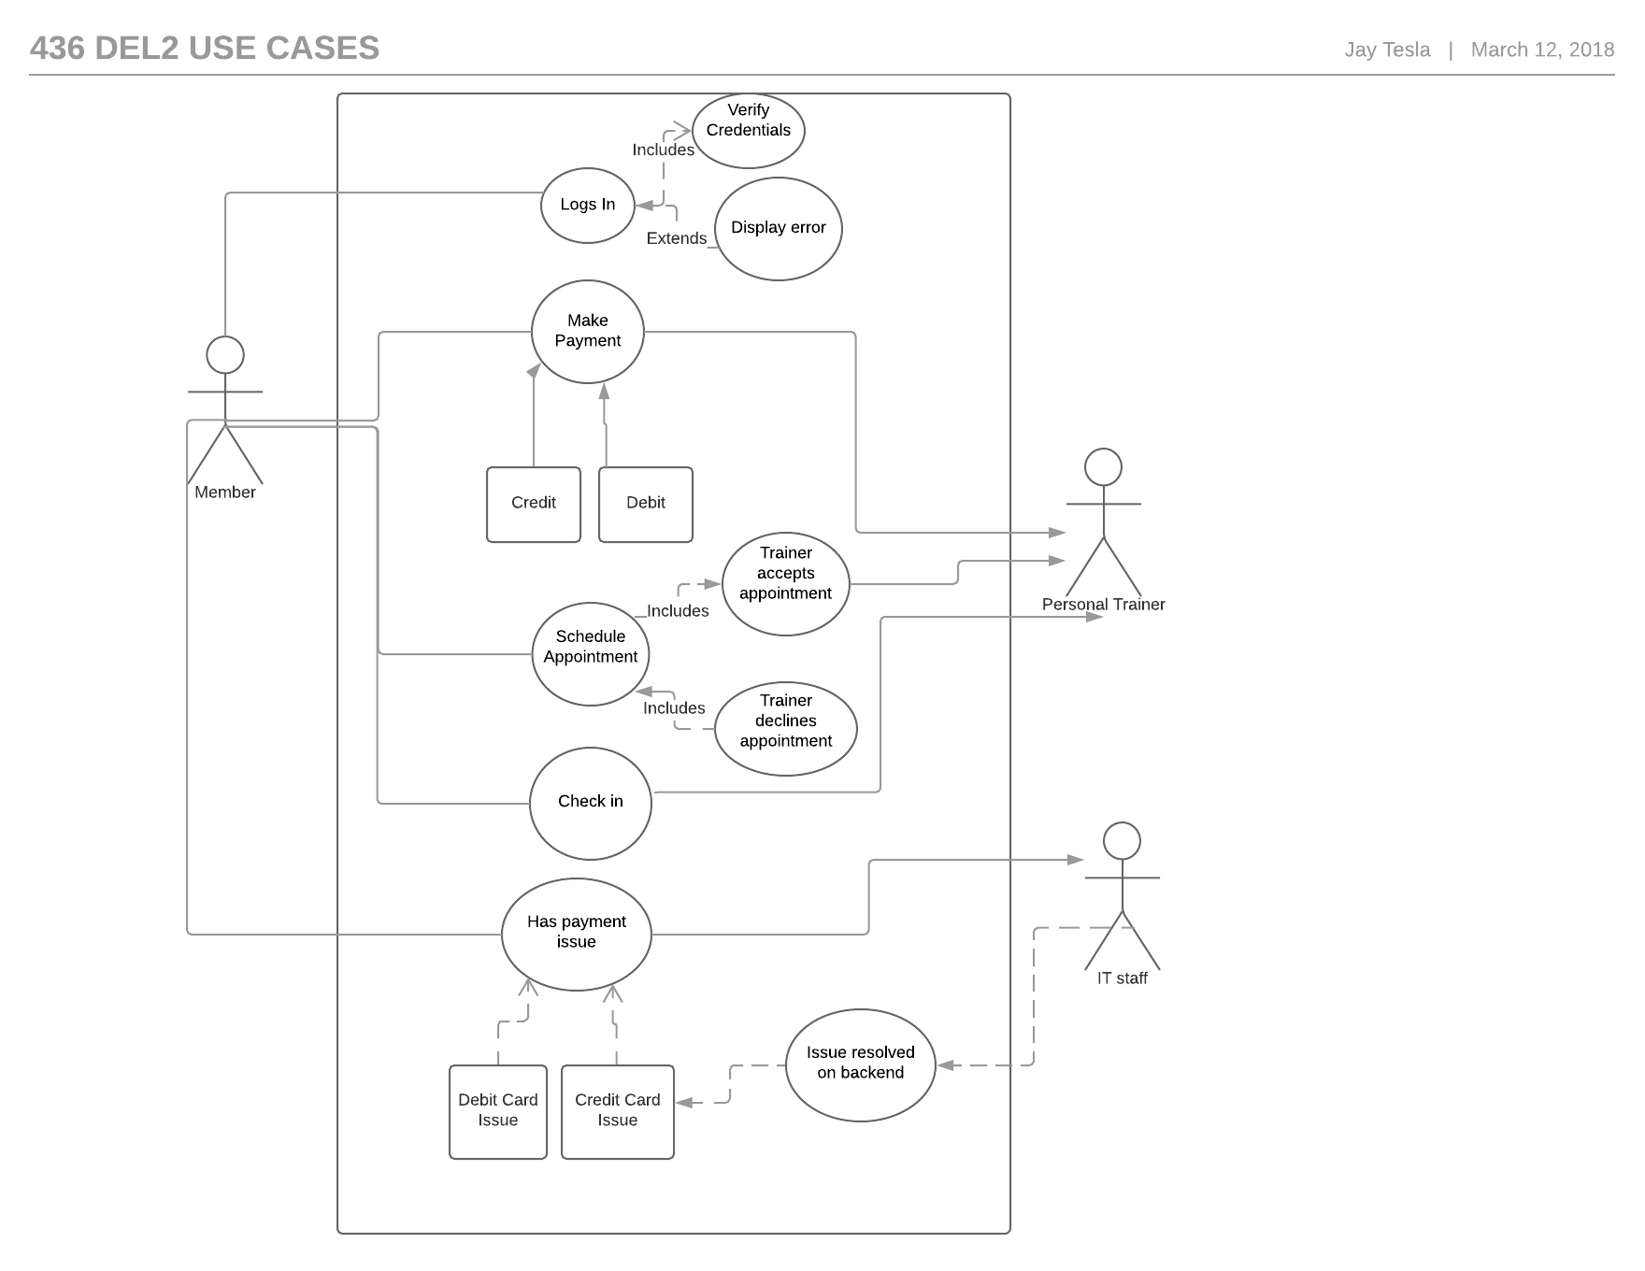

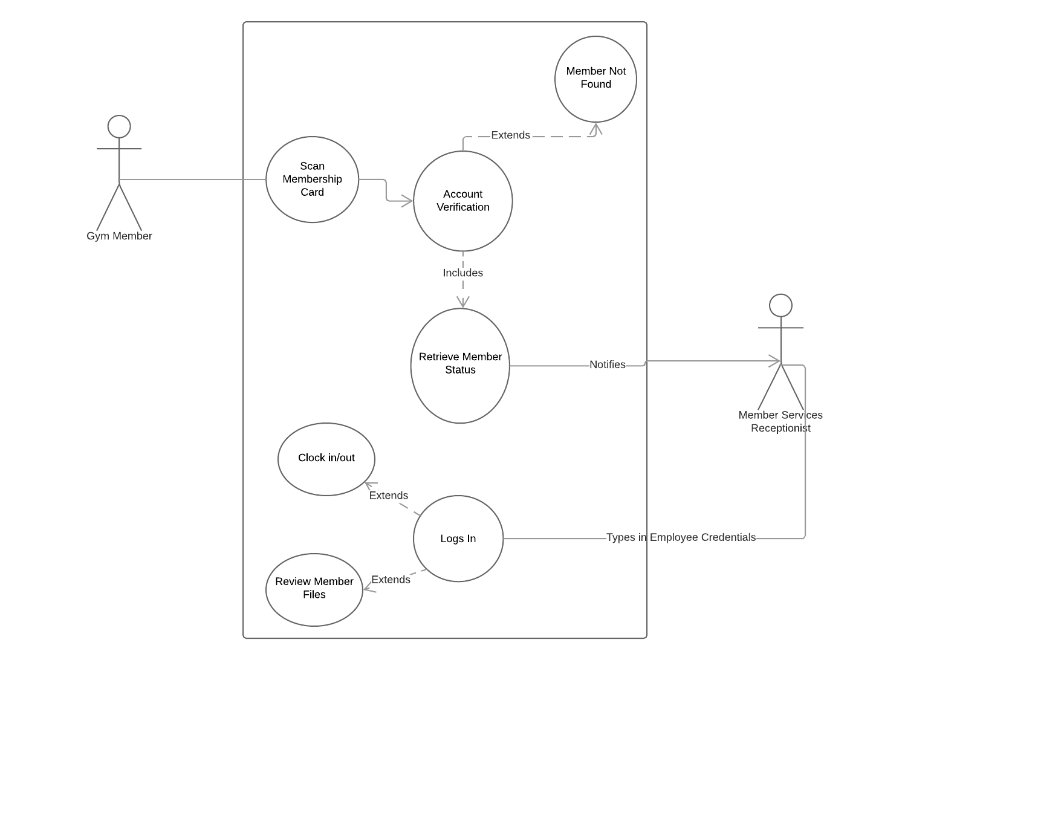

Link to Use Case Documents: <https://docs.google.com/spreadsheets/d/1LEbP5-DgKqFgOjhVRLaDg8xJwi32F54wRe5uYMjf2tc/edit#gid=0>